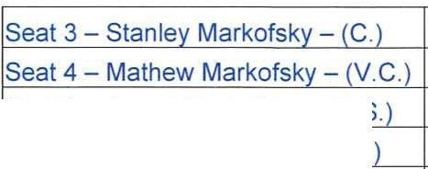
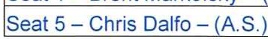
Waterstone

!Seat 2 - Jarrod Markofsky - (A.S.
!Seat 1 - Brent Markofsky - (A.S.
Community Development District
Agenda

Thursday August 5, 2021
11:00 a.m.
2160 NW Reserve Park Trace Port St. Lucie, Florida 34986 https://global.gotomeeting.com/join/613629837
+1 (646) 749-3122; Access Code: 613-629-837

- Roll Call

- Approval of the Minutes of the July 1, 2021 Meeting

- Ratification of Upland Preserves Exotic Vegetation Treatment/Removal Event and Regularly Scheduled Maintenance Activities Proposal with EcoTech Environmental LLC

- Approval of Invoice with Abercrombie's Land Services, LLC

- Approval of Invoice with SPF Underground Utilities, Inc.

- Staff Reports
  - Attorney
  - Engineer
  - Field Manager
  - Manager
    - Discussion of Financial Disclosure Report from the Commission on Ethics and Reminder to File Annual Form - everyone has filed

- Financial Statements
  - Approval of Check Run Summary
  - Balance Sheet and Income Statement

- Supervisors Requests and Audience Comments

- Adjournment

Meetings are open to the public and may be continued to a time, date and place certain. For more information regarding this CDD please visit the website: http://www.waterstonecdd.com

