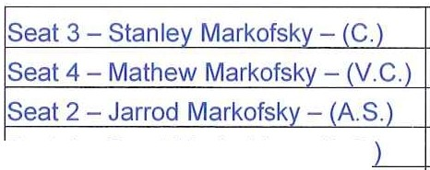
Waterstone

!Seat 1 - Brent Markofsky - (A.S.
!Seat 5 - Chris Dalfo - (A.S.
Community Development District
Communications Media Technology Meeting Agenda

Thursday August 6, 2020
11:00 a.m.
https://global.gotomeeting.com/join/544561581
+1 (646) 749-3122; Access Code: 544-561-581
2160 NW Reserve Park Trace, Port St. Lucie, Florida 34986

In accordance with Office of the Governor, ExecutiveOrders authorizing the use of communications media technology, the Board of Supervisors and members of the public may attend and participate in the meeting utilizing the call-in information above, and if the Executive Order is not extended to include this meeting date, the meeting will be held at the physical addressabove.

- Roll Call

- Approval of the Minutes of the October 3, 2019 and May 6, 2020 Meetings

- Public Hearing to Adopt the Fiscal Year 2021 Budget
A Motion to Open the Public Hearing

- Public Comment and Discussion

- Consideration of Resolution #2020-04 Annual Appropriation Resolution

- Consideration of Resolution #2020-05 Levy of Non Ad Valorem Assessments

- Motion to Close the Public Hearing

- Public Hearing to Adopt the Rules of Procedure
A Motion to Open the Public Hearing

- Public Comment and Discussion

- Adoption of Resolution #2020-06

- Motion to Close the Public Hearing

- Consideration of Service Agreement with Everclear Pool

- Field Management Agreement with Pinnacle Association Management, LLC

- Consideration of Proposals from:
A Monthly Aquatic Weed Control with Mallard Environmental Services, LLC

- Control of Exotic and Nuisance Species for the Wetlands from Mallard Environmental Services, LLC

- Eco-Tech Environmental for Wetland Maintenance

- Consideration of Landscaping Proposal from Robertson's Lawns Inc.

- Approval of the Execution of the St. Lucie County Planning & Development Services Department - Application and Authorization of ChairmanNice Chairman to execute the Plat of Waterstone - Phase Three after Attorney and Engineer review

- Staff Reports
  - Attorney

  - Engineer

  - Manager
    - Consideration of Proposed Fiscal Year 2021 Meeting Schedule

    - Discussion of Financial Disclosure Report from the Commission on Ethics - everyone has filed

- Supervisors Requests and Audience Comments

- Financial Statements
  - Approval of Check Run Summary

  - Balance sheet and Income statement

- Adjournment

Meetings are open to the public and may be continued to a time, date and place certain. For more information regarding this CDD please visit the website: http://www.waterstonecdd.com

