Waterstone
Community Development District
Special Meeting Agenda

Thursday
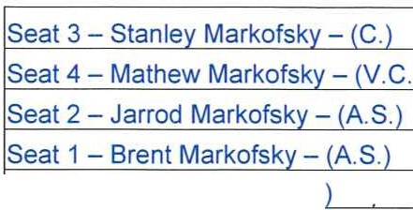

!Seat 5 - Chris Daito - (A S.
Port St. Lucie Community Center

July 1, 2021
11:00 a.m.
2195 SE Airoso Blvd., Port St. Lucie FL 34984 https://global.gotomeeting.com/join/907959077
+1 (571) 317-3122; Access Code: 907-959-077

Due to the current State of Emergency throughout the State of Florida, in order to reduce risk of COVID-19 and transmission of the virus, and in accordance with Executive Orders authorizing the use of communications media technology, members of the public are encouraged to participate in the meeting utilizing the information above.

- Roll Call

- Approval of the Minutes of the June 3, 2021 Meeting

- Public Hearing to Adopt the Fiscal Year 2022 Budget
  - Motion to Open the Public Hearing
  - Public Comment and Discussion
  - Consideration of Resolution #2021-04 Annual Appropriation Resolution
  - Consideration of Resolution #2021-05 Levy of Non Ad Valorem Assessments
  - Motion to Close the Public Hearing

- Consideration of Clubhouse Cleaning Services with:
  - Crystal Clean Team, Inc.
  - Smart Mama Clean Quality Services
  - Bianca's Cleaning Services

- Staff Reports
  - Attorney
  - Engineer
  - Field Manager
  - Manager
    - Consideration of Proposed Fiscal Year 2022 Meeting Schedule
    - Discussion of Financial Disclosure Report from the Commission on Ethics and Reminder to File Annual Form

- Financial Statements
  - Approval of Check Run Summary
  - Balance Sheet and Income Statement

- Supervisors Requests and Audience Comments

- Adjournment

Meetings are open to the public and may be continued to a time, date and place certain. For more information regarding this COD please visit the website: http://www.waterstonecdd.com

