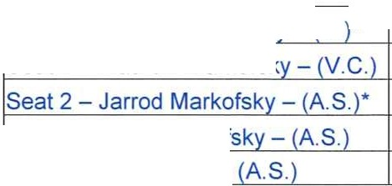

Waterstone
! Seat 3 - Stanley Markofsky - (C.' *
!Seat 4 - Mathew Markofsky - (V.C.
!Seat 1 - Brent Markof
!Seat 5 - Chris Dalfo -
Community Development District
REVISED Agenda

Thursday June 3, 2021
11:00 a.m.
2160 NW Reserve Park Trace Port St. Lucie, Florida 34986 https://global.gotomeeting.com/join/911170565
+1 (872) 240-3212; Access Code: 911-170-565

Due to the current State of Emergency throughout the State of Florida, in order to reduce risk of COVID-19 and transmission of the virus, and in accordance with Executive Orders authorizing the use of communications media technology, members of the public are encouraged to participate in the meeting utilizing the information above.

- Oath of Office for Mr. Stanley Markofsky and Mr. Jarrod Markofsky

- Roll Call

- Approval of the Minutes of the May 6, 2021 Meeting

- Discussion of Opening the Clubhouse 7 Days a Week and Cleaning 4 Days a Week

- Authorization of Chair or Vice Chair to Approve Proposals - Not to Exceed Dollar Amount

- Ratification of:
  - Chairman Authorization to Execute Waterstone Phase 4 in the amount of $140,988
  - Vice Chairman Authorization to Execute FPL Phase 3

- Approval of Subdivision Improvement Agreement

- Staff Reports
  - Attorney

  - Engineer

  - Field Manager - Consideration of Proposal for Alligator Signs and Installation with Traffic Supplies
& Distribution LLC

  - Manager

- Financial Statements
  - Approval of Check Run Summary
  - Balance sheet and Income statement

- Supervisors Requests and Audience Comments

11 .Adjournment

Meetings are open to the public and may be continued to a time, date and place certain. For more information regarding this CDD please visit the website: http://www.waterstonecdd.com

