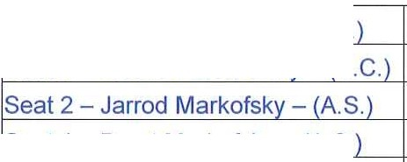

Waterstone
!Seat 3 - | Stanley Markofsky |  | - | (C.
!Seat 4 - Mathew Markofsky - (V.C.

ISeat 1 - Brent Markofsky - (A.S.
!Seat 5 - | Chris Dalfo - | (A S.

Community Development District
Agenda

Thursday October 1, 2020
11:00 a.m.
2160 NW Reserve Park Trace Port St. Lucie, Florida 34986 https://global.gotomeeting.com/join/545514077
+1 (646) 749-3122; Access Code: 545-514-077

- Roll Call

- Approval of the Minutes of the September 3, 2020 Meeting

- Consideration of Proposal for Preserve Maintenance
  - Lakes and Wetlands Management

  - Mallard Environmental Services, LLC

  - Eco-Tech Environmental

- Consideration of Proposals with:
  - Royal Treatment Services for Cleaning the Clubhouse

  - Hanna Painting Plus, LLC for Pressure-Washing

  - Reynolds Pest Management

  - T. C. A. Fitness Services for Preventative Maintenance Services

  - Everclear Pool USA, LLC

  - Elite Christmas Lighting

- Staff Reports
  - Attorney

  - Engineer

  - Manager

- Supervisors Requests and Audience Comments

- Financial Statements
  - Approval of Check Run Summary

  - Balance sheet and Income statement

- Adjournment

Meetings are open to the public and may be continued to a time, date and place certain. For more information regarding this CDD please visit the website: http://www.waterstonecdd.com.

